**Lincoln IELTS Mock Test**

**SECTION 1**

#### ****Questions 1 – 10****

Complete the form below.

Write ****ONE WORD AND/OR A NUMBER**** for each answer.

### ****Customer Satisfaction Survey****

****Customer details****

Name:                                                               Sophie Bird

Occupation:                                                     ****1****……………..

Reason for travel today:                               ****2****……………..

****Journey information****

Name of station returning to:                    ****3****……………..

Type of ticket purchased:                             Standard ****4****……………… ticket

Cost of ticket:                                                  ****5**** £…………….

When ticket was purchased:                       Yesterday

Where ticket was bought:                           ****6****………………

****Satisfaction with journey****

Most satisfied with:                                       the wifi

Least satisfied with:                                      the ****7****…………….. this morning.

****Satisfaction with station facilities****

Most satisfied with:                                       how much ****8****…………… was provided

Least satisfied with:                                      lack of seats, particularly on the ****9****………………

Neither satisfied nor dissatisfied with:     the ****10****……………… available

### ****SECTION 2****

#### ****Questions 11 – 16****

Label the map below.

*Write the correct letter,******A-H******, next to Questions******11-16*****

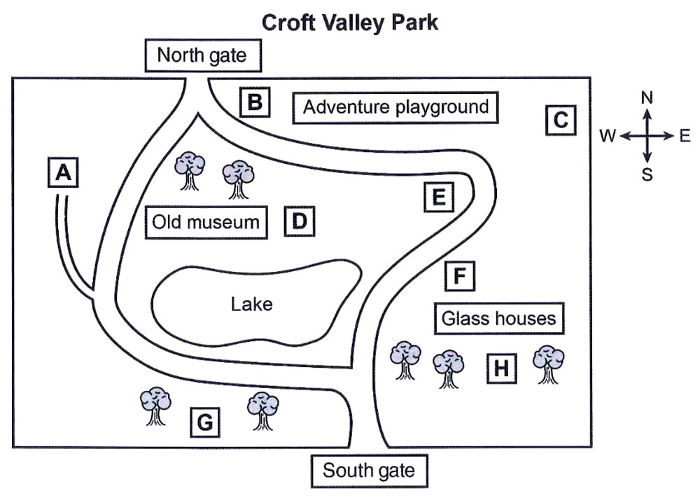

****11****   café                             ……………

****12****   toilets                          ……………

****13****   formal gardens         ……………

****14****   outdoor gym             ……………

****15****   skateboard ramp      ……………

****16****   wild flowers               ……………

#### ****Questions 17 and 18****

Choose ****TWO**** letters, ****A-E****.

What does the speakers say about the adventure playground?

****A****     Children must be supervised.

****B****    It costs more in winter.

****C****    Some activities are only for younger children.

****D****     No payment is required.

****E****     It was recently expanded.

#### ****Questions 19 and 20****

What does the speaker say about the glass houses?

****A****     They are closed at weekends.

****B****     Volunteers are needed to work there.

****C****     They were badly damaged by fire.

****D****    More money is needed to repair some of the glass.

****E****    Visitors can see palm trees from tropical regions.

### ****SECTION 3****

#### ****Questions 21 – 24****

Choose the correct letter, ****A****, ****B**** or ****C****.

#### ****Presentation about refrigeration****

****21****   What did Annie discover from reading about icehouses?

****A****   why they were first created

****B****   how the ice was kept frozen

****C****   where they were located

****22****   What point does Annie make about refrigeration in ancient Rome?

****A****   It became a commercial business.

****B****   It used snow from nearby.

****C****   It took a long time to become popular.

****23****   In connection with modern refrigerator, both Annie and Jack are worried about

****A****   the complexity of the technology.

****B****   the fact that some are disposed of irresponsibly.

****C****   the large number that quickly break down.

****24****   What do Jack and Annie agree regarding domestic fridges?

****A****   They are generally good value for money.

****B****   There are plenty of useful variations.

****C****   They are more useful than other domestic appliances.

#### ****Questions 25-30****

Who is going to do research into each topic?

Write the correct letter, ****A****, ****B**** or ****C****, next to Questions ****25-30****.

****People****

****A****     Annie

****B****     Jack

****C****     both Annie and Jack

****Topics****

****25****   the goods that are refrigerated          ……………

****26****   the effects on health                             ……………

****27****   the impact on food producers            ……………

****28****   the impact on cities                               ……………

****29****   refrigerated transport                           ……………

****30****   domestic fridges                                     ……………

### ****SECTION 4****

#### ****Questions 31 – 40****

Complete the notes below.

Write ****ONE WORD ONLY**** for each answer.

## ****How the Industrial Revolution affected life in Britain****

****19th century****

●   For the first time, people’s possessions were used to measure Britain’s ****31****…………….. .

●   Developments in production of goods and in ****32****……………… greatly changed lives.

****MAIN AREAS OF CHANGE****

****Manufacturing****

●   The Industrial Revolution would not have happened without the new types of ****33****……………… that were used then.

●   The leading industry was ****34****………………. (its products became widely available).

●   New ****35****…………….. made factories necessary and so more people moved into towns.

****Transport****

●   The railways took the place of canals.

●   Because of the new transport:

      –  greater access to ****36****………………. Made people more aware of what they could buy in shops.

      –  when shopping, people were not limited to buying ****37****……………… goods.

****Retailing****

●   The first department stores were opened.

●   The displays of goods were more visible:

      –  inside stores because of better ****38****………………. .

      –  outside stores, because ****39****……………… were bigger.

****●   40****………………. that was persuasive became much more common.

**Answers:**

|  |  |  |  |
| --- | --- | --- | --- |
| **Part 1** 1   journalist  2   shopping  3   Staunfirth  4   return  5   23.70  6   online  7   delay  8   information  9   platform(s)  10   parking | **Part 2** 11   D  12   C  13   G  14   H  15   A  16   E  17&18   A, D  19&20   A, C | **Part 3** 21   B  22   A  23   B  24   A  25   A  26   A  27   B  28   B  29   A  30   C | **Part 4** 31   wealth  32   technology  33   power  34   textile(s)  35   machines  36   newspapers  37   local  38   lighting  39   windows  40   Advertising |